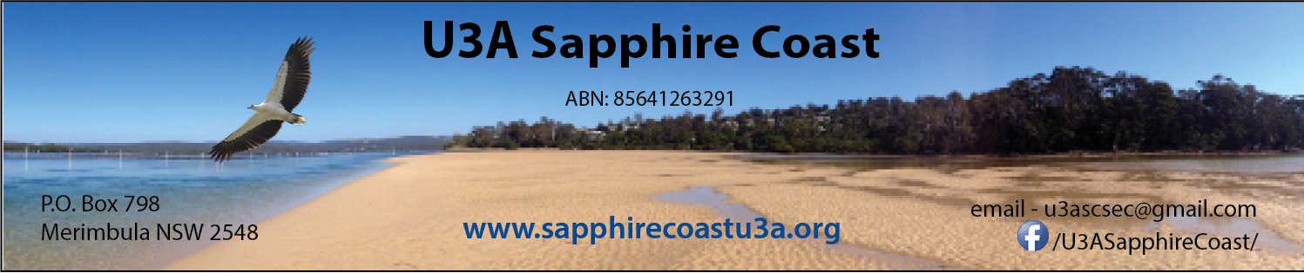
Management Team Meeting Minutes – 27 October 2022
Club Sapphire.

Present: Paul Strutynski, Carolyn Smith, Garry Clear, Julie Novotny, Judy Brand, Sue O’Loughlin, Merryn Dowling

Apologies : Roger Harris, Sue Fowler

- Paul Welcomed all present.

- Minutes from previous meeting: Minutes from meeting held 22 September accepted as true and accurate Moved: Sue Seconded: Garry

- Business arising from previous meeting:
- Senior’s Festival Update – waiting for Council to announce grants/plans and priorities. Ideas canvassed …..
- Christmas party update – Bookings are coming in with 8 cash/card payments and 23 on Trybooking to date. Entertainment has been organized, Paul Daines needs 2 hours to set up so Sue will arrange access and assist. The recorder group are organized, program order is Loose Change, Recorders, Christmas Music during meal, Loose Change after meal. Sue and Paul have donated a painting by local artist John Sharman as a lucky door prize.
- Website Update – Terry Prowse has updated as requested. Fine tuning still required.

- Correspondence:
- Dept Fair Trading – changes noted to model constitution. Need to amend our constitution to incorporate changes voted on in 2020. Merryn
- U3A Network Census – our contact details have been updated, Census to commence end October which will form the basis for our insurance.

- Treasurer’s Report (emailed)
Noted that finances are trending as expected – a small deficit is predicted. Motion: Report to be accepted and that payments listed in the cashbook and bank reconciliation are accepted and approved. Moved: Carolyn Seconded: Sue

- Brief update from team leaders:
- Program Team: Sue reported that 36 invitations have been sent for the Course Leaders Thank You Afternoon Tea on 11th November at TBC. Management Team are encouraged to attend. Catering is an issue due to small program team – agreed to use Bakery next door. Approved in principle to spend over $100 if necessary. A few one offs are planned for the next few weeks. Attendances have increased – 14 or 15 for each session. We are promoting an Oyster Tour at Pambula for Bermagui U3A.
- Team Office: Michele’s report noted – great work. Difficulties not being able to use TBC noted. Possibly the printer will work at TBC?
- Newsletter Team: Paul reported that the team had met, all going well, nothing significant to report.
- Publicity: Julie has increased postings on Facebook, and she presented some statistics indicating an increase in interest and reach, with more views, likes and followers, and our pages being shared with other community noticeboards.

- Grants and Submissions Update:
- We should hear from Paul’s application in the next month. Noted Mumbulla have an event as a grants opener on Saturday. Julie is attending and will represent U3A.
- Current Grant Opportunities and Grant wishlist – Computers, Air conditioner for TBC pending partitioning, Buses for excursions

- Other Business
- Tura Centre Update. We are currently waiting for a Structural Engineer’s inspection, meanwhile the back area is being used with entry through the back door. Need to secure cash – a small cash box to be purchased. Discussed risk assessments – Carolyn to check First Aid and update as required. It may be necessary to move modem before repairs start.
- Attendance recording for insurance. Insurance company will not be definitive about what is required, beyond that there needs to be some form of reportage kept for 7 years, which needs ‘detailed and descriptive information’ about the incident. It was decided not to change anything at this point, but wait for further information from Bermagui and the Chair of U3A Network. It was considered that incident reports should be sufficient, with the onus on the member to complete the report in a timely manner, to be signed off by the course leader and then deposited with a nominated member of the Management Team (Carolyn). All course leaders including those running one off sessions should to be aware of the need for Incident Reports for all incidents, however minor. Course leaders using their own premises must be aware that they need public liability insurance to cover any incidents. Team Office should keep the processing of attendance records on hold until a final decision is made.
- ABN vs Association status. Our ABN describes us as an unincorporated association. We need to change this description with Tax office or cancel ABN. Currently awaiting advice from Chris Bembrick.
- President’s column – Christmas Party, Incident reports, Team Office at Club Sapphire

Meeting Concluded: 3.15 Next Meeting: 24 November 2022

