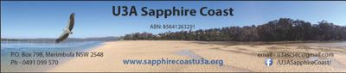
Agenda: Management Team Meeting

Date: 14 November , 2019 Venue: Rockpool Cafe
Meeting Commenced: Chair: Fleur
Present:
Apologies : Kaye Separovic
Welcome:
Business Arising from Previous Meeting:
- Seniors Festival – has anyone thought of ideas in regard to U3A participation in this for 2020

- Renovation of U3ASC Tura Beach Centre.
Action: Carole to try and identify sections of work which can be completed as funding is available from our interest-bearing accounts
- Membership renewal drive – Team Office update
- Succession for 2020 – who will/will not be continuing as a member of MT? Fleur
- Planning for Christmas Party – how are numbers looking and other plans for the day progressing – Team Social
- Third Party Insurance - Chris

Treasurer’s Report:

General Business:

